# EC2 and EFS Case Study

1. EC2 Linux Instance in US-East-1  
   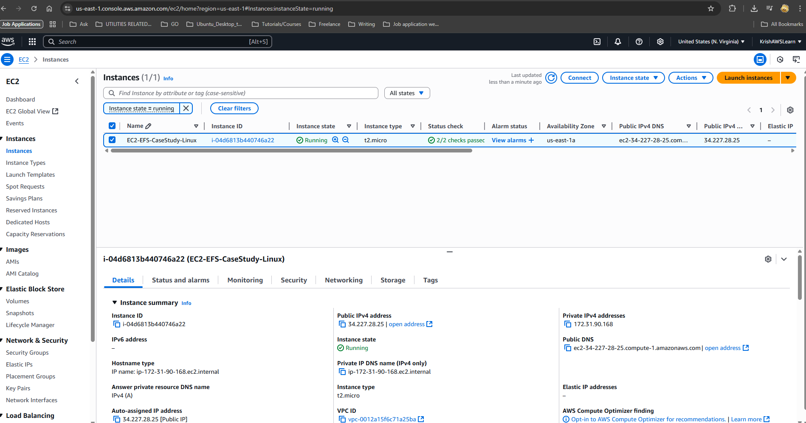  
     
   Connected to the Instance  
   A screenshot of a computer

   AI-generated content may be incorrect.  
     
   AMI from the Instance  
   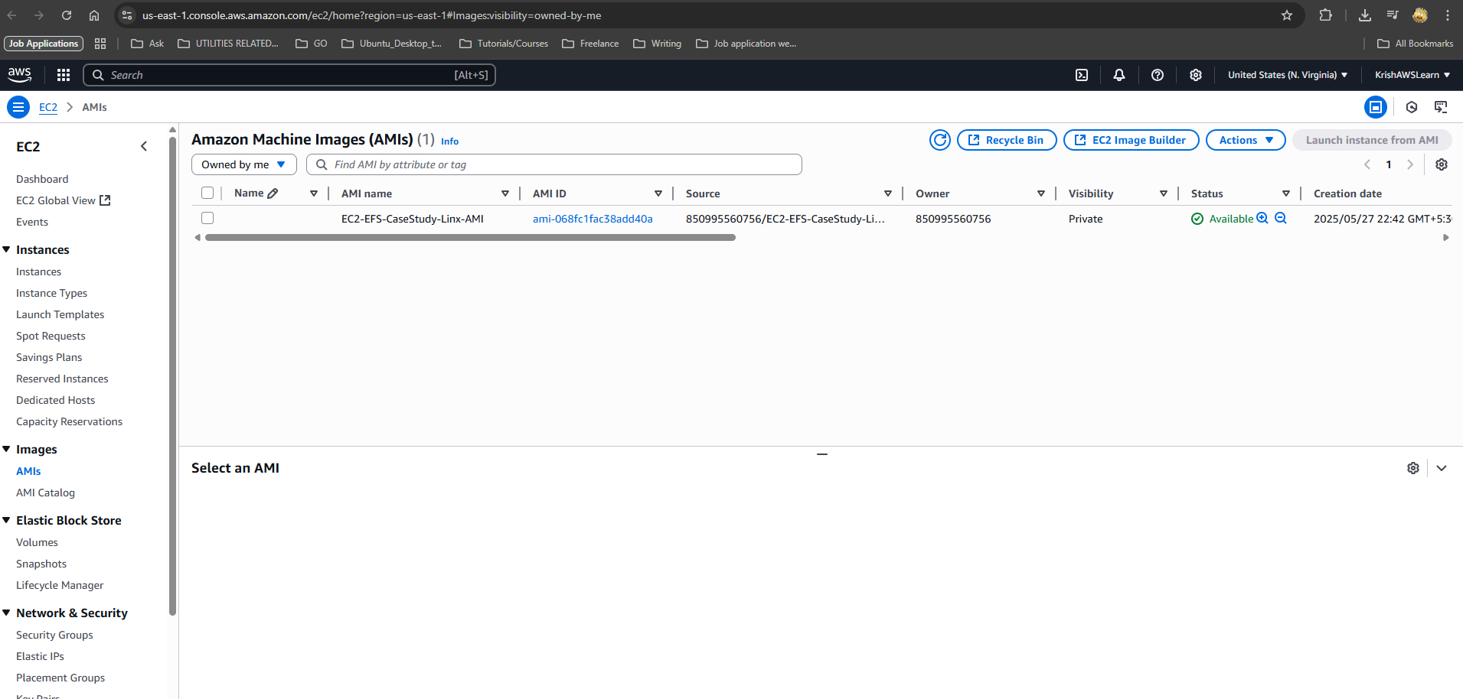  
     
   Web Server on the instance  
   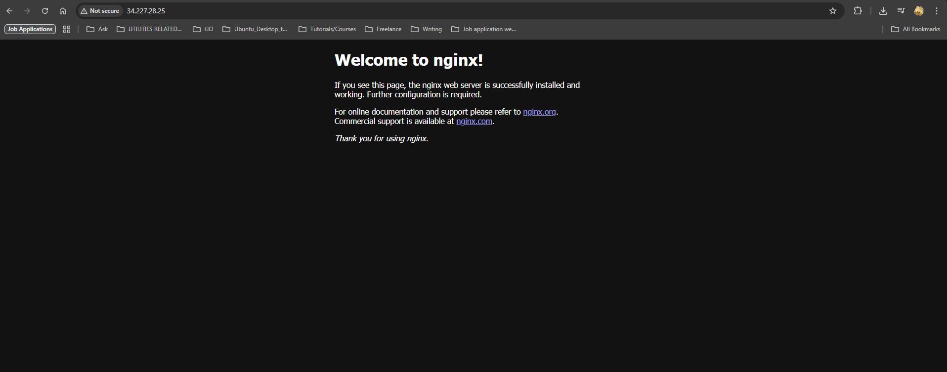
2. Replication of US-East-1 instance to US-West-2  
     
   Copied Image/AMI from US-East-1  
     
   A screenshot of a computer

   AI-generated content may be incorrect.   
     
   Launched Instance from Copied AMI  
   A screenshot of a computer

   AI-generated content may be incorrect.  
     
     
     
   Running Web Server in US-West-2  
   A screenshot of a computer

   AI-generated content may be incorrect.
3. Build Two EBS volume attach them to US-East-1  
     
   EBS vol-1  
   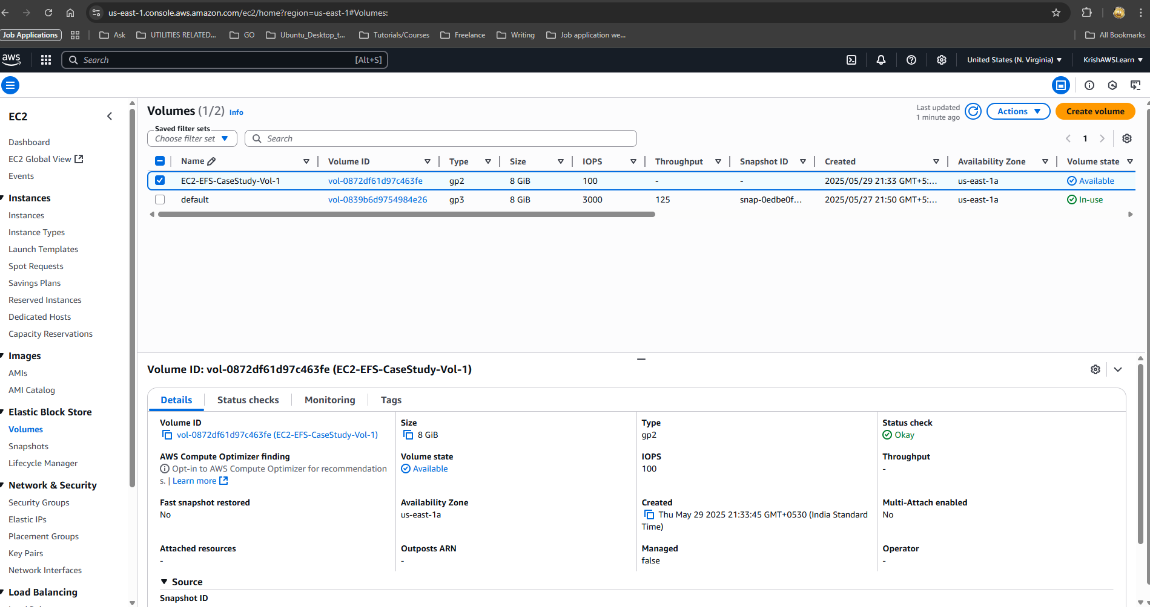  
     
   Vol-1 Attach and mounted  
   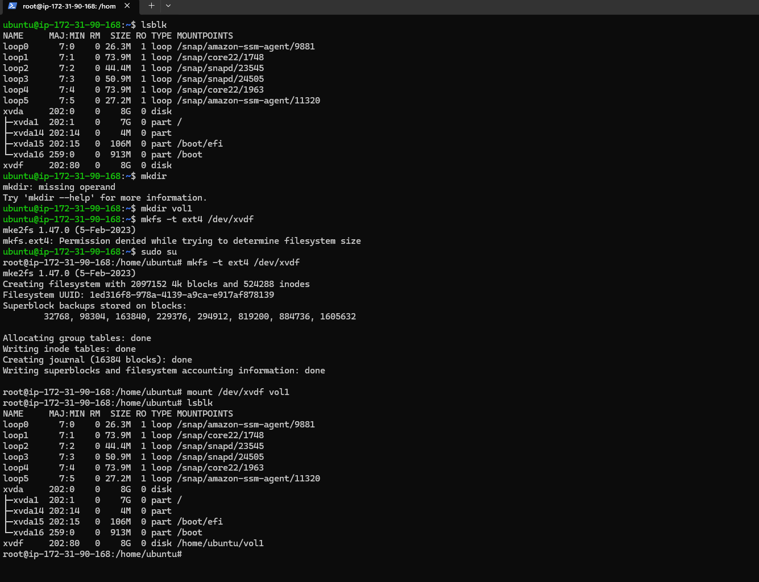  
     
     
     
     
     
     
     
     
     
     
     
     
     
     
     
     
     
   Vol-2  
   A screenshot of a computer

   AI-generated content may be incorrect.  
     
   Vol-2 attach and mount  
   A screenshot of a computer

   AI-generated content may be incorrect.
4. Delete one volume and increase one vol-1  
     
   Vol-1 deleted  
   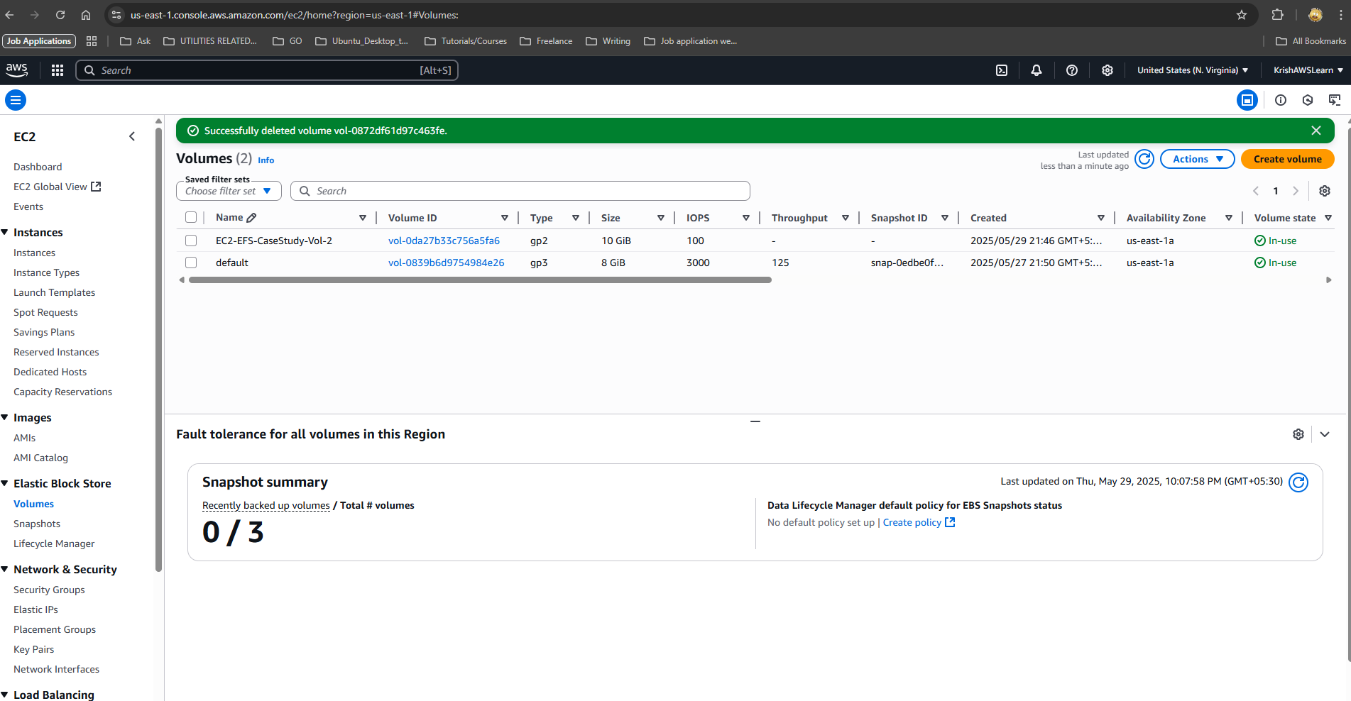  
     
   vol-2 increased  
   A screenshot of a computer

   AI-generated content may be incorrect.  
     
   A screenshot of a computer

   AI-generated content may be incorrect.
5. Backup of EBS(snapshot)  
   